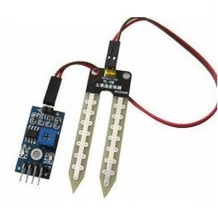
This project use Moisture sensor to detect water and air. When the sensor is put into water, the LED will turn off, if the sensor is exposed to air, LED will turn on.
Step 1:Connect sensor to Arduino as per following graph:

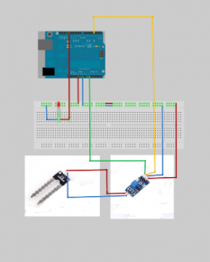
Step 2:Download Sample code and load it into Arduino.
Step 3: Run the code and you will see the result same as following video.

